SEPARATE CODES FOR WEBPAGES

HCI ASSIGNMENT 5

* CSS PROPERTIES USED

1.HOME PAGE(NAVIGATION)

HTML CODE

<!DOCTYPE html>

<html lang="en">

<head>

<meta charset="UTF-8">

<meta name="viewport" content="width=device-width, initial-scale=1.0">

<title>Photography Website</title>

<link rel="stylesheet" href="style.css">

<link href="https://fonts.googleapis.com/css2?family=Lobster&family=Lora&display=swap" rel="stylesheet">

</head>

<body>

<header>

<nav class="navbar">

<h3><span>Nature's</span> Click</h3>

<ul class="navigation">

<li class="item"><a class="active" href="#">HOME</a></li>

<li class="item"><a href="#">PORTFOLIO</a></li>

<li class="item"><a href="#">ABOUT ME</a></li>

<li class="item"><a href="#">CONTACT US</a></li>

</div>

</div>

</div>

</div>

</ul>

</nav>

<h4><span>Nature's Beauty at its Best</span></h4>

<div id="phone">

<a href="tel:+919665342097">+919665342097

</a>

</div>

</header>

</body>

</html>

CSS CODES

body{

margin: 0;

padding: 0;

color: black;

}

header:before{

content: "";

background: url('https://cdn.pixabay.com/photo/2014/04/14/20/11/pink-324175_960_720.jpg') no-repeat center center/cover;

position: absolute;

top: 0;

left: 0;

width: 100%;

height: 100%;

z-index: -1;

}

.navbar{

display: flex;

justify-content: space-between;

}

h3 span{

font-size: 2.2rem;

margin-left: 30px;

color: White;

margin-top: 50px;

width: 300px;

height: 300px;

font-family: 'Lobster', cursive;

color: coral;

}

h3 span

{

color: purple;

}

h4{

font-size: 1.2rem;

margin-left: 25px;

font-family: 'fantasy;', cursive;

color: hotpink;

}

h4 span{

color:brown ;

}

.navigation{

font-size: 20px;

display: flex;

}

li{

list-style: none;

margin-right: 30px;

margin-top: 20px;

}

li a{

padding: 2px 23px;

font-family: 'Lobster', cursive;

text-decoration: none;

color: black;

font-size: 1.3rem;

font-weight: bold;

}

li a:hover{

background-color: coral;

color: black;

transition: 0.6s ease;

}

li a.active{

border: 2px solid black;

}

Webpage:-

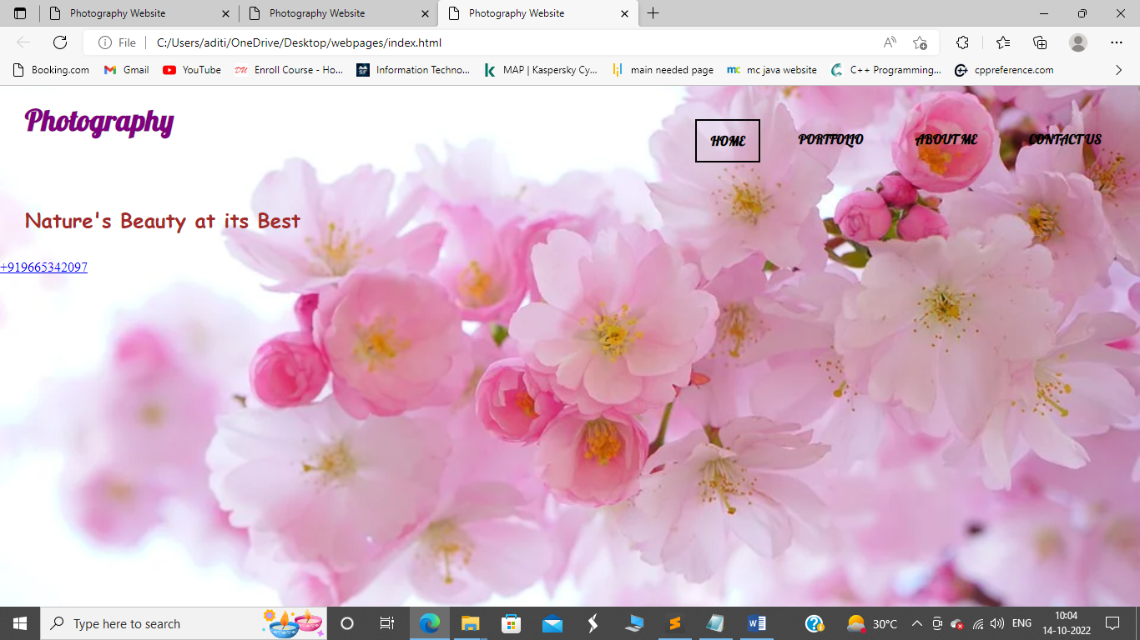

2.HOMEPAGE(BORDER)

//BORDER WAS ADDED TO THE HEADING

THEREFORE ITS HTML AND CSS CODES ARE AS FOLLOWS

HTML CODE

<!DOCTYPE html>

<html lang="en">

<head>

<meta charset="UTF-8">

<meta name="viewport" content="width=device-width, initial-scale=1.0">

<title>Photography Website</title>

<link rel="stylesheet" href="style.css">

<link href="https://fonts.googleapis.com/css2?family=Lobster&family=Lora&display=swap" rel="stylesheet">

</head>

<body>

<header>

<nav class="navbar">

<h3><span>Photography</span></h3>

</header>

</body>

</html>

CSS CODES

h3 span{

font-size: 2.2rem;

margin-left: 30px;

color: White;

margin-top: 50px;

width: 300px;

height: 300px;

font-family: 'Lobster', cursive;

color: coral;

border-style: solid;

border-color: goldenrod;

}

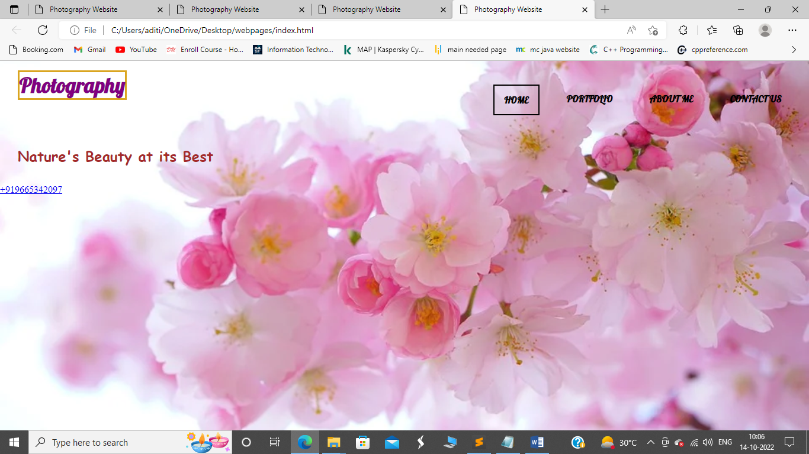

3. HOME-PAGE(MARGIN)

4. HOME-PAGE(PADDING)

TO DEMONSTRATE THE USE OF MARGIN I HAVE ALREADY USED THE SCREEN VIEW OF ANOTHER IMAGE

HTML CODE

<!DOCTYPE html>

<html lang="en">

<head>

<meta charset="UTF-8">

<meta name="viewport" content="width=device-width, initial-scale=1.0">

<title>Photography Website</title>

<link rel="stylesheet" href="style.css">

<link href="https://fonts.googleapis.com/css2?family=Lobster&family=Lora&display=swap" rel="stylesheet">

</head>

<body>

<header>

<nav class="navbar">

<h3><span>Photography</span></h3>

<section>

<div class="container">

<div class="gallery">

<img src="https://upload.wikimedia.org/wikipedia/commons/4/4d/Apis_mellifera_Western_honey_bee.jpg " alt="">

</div>

<div class="button">

<button class="btn">Explore Now</button>

<button class="btn">Premium</button>

<div class="navbar">

</div>

</div>

</div>

</div>

</section>

CSS CODE

.gallery img{

margin-top: 50px;

width: 300px;

height: 300px;

}

.gallery img:hover{

width: 301px;

height: 301px;

transition: 0.1s ease;

}

.button{

display: flex;

flex-direction: column;

margin-right: 60px;

}

.gallery img{

margin-top: 50px;

width: 300px;

height: 300px;

}

.gallery img:hover{

width: 301px;

height: 301px;

transition: 0.1s ease;

}

.button{

display: flex;

flex-direction: column;

margin-right: 60px;

}

.btn{

font-family: 'Lobster', cursive;

color: coral;

font-size: 1.2rem;

padding: 10px 30px;

border-radius: 25px;

margin: 5px;

cursor: pointer;

border: 2px solid coral;

}

.btn:hover{

color: black;

background-color: coral;

transition: 0.4s ease;

}

PADDING

for padding, I have used the gallery image same used to describe the margin, although this won’t show any change in the HTML code, it does affect your webpage.

HTML CODE

<!DOCTYPE html>

<html lang="en">

<head>

<meta charset="UTF-8">

<meta name="viewport" content="width=device-width, initial-scale=1.0">

<title>Photography Website</title>

<link rel="stylesheet" href="style.css">

<link href="https://fonts.googleapis.com/css2?family=Lobster&family=Lora&display=swap" rel="stylesheet">

</head>

<body>

<header>

<nav class="navbar">

<h3><span>Photography</span></h3>

</header>

<section>

<div class="container">

<div class="gallery">

<img src="https://cdn.pixabay.com/photo/2014/02/27/16/10/flowers-276014__340.jpg" alt="">

</div>

<div class="button">

<button class="btn">Explore Now</button>

<button class="btn">Premium</button>

<div class="navbar>

</div>

</div>

</div>

</div>

</section>

CSS CODE

.gallery img{

margin-top: 50px;

width: 300px;

height: 300px;

padding: 5px 10px 15px 20px; //top right bottom left

padding: 10px 20px;//top & bottom then left & right

padding-top: 5px; //just top padding

padding-right: 10px; //just right padding

padding-bottom: 15px; //just bottom padding

padding-left: 20px; //just left padding

}

.gallery img:hover{

width: 301px;

height: 301px;

transition: 0.1s ease;

}

.button{

display: flex;

flex-direction: column;

margin-right: 60px;

}

.btn{

font-family: 'Lobster', cursive;

color: coral;

font-size: 1.2rem;

padding: 10px 30px;

border-radius: 25px;

margin: 5px;

cursor: pointer;

border: 2px solid coral;

}

.btn:hover{

color: black;

background-color: coral;

transition: 0.4s ease;

}

OUTPUT:-

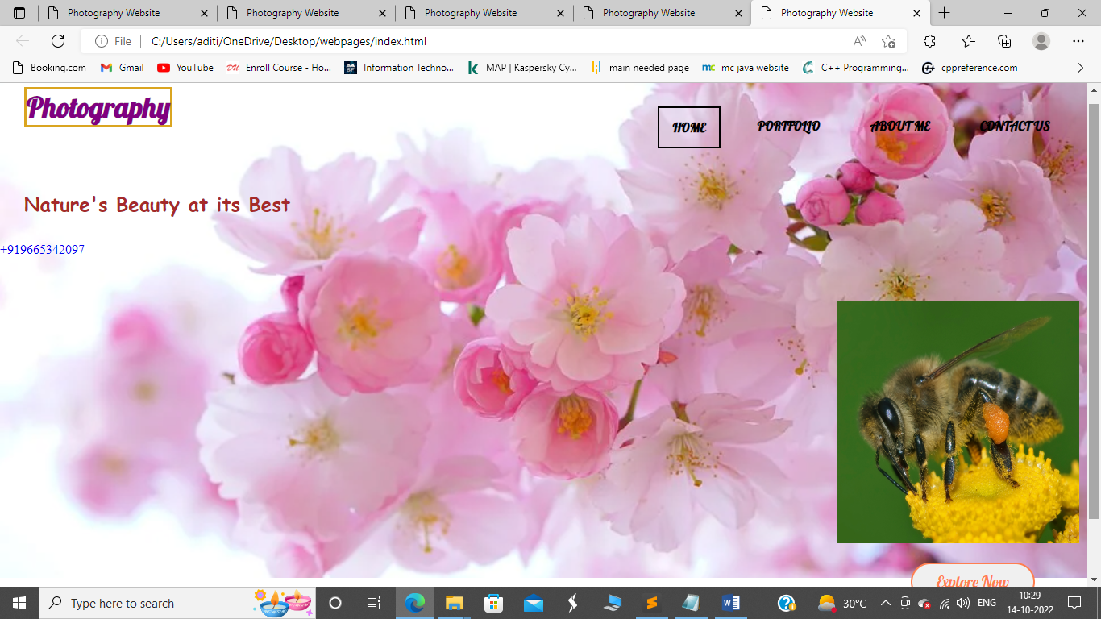

5.HOME PAGE(DROPDOWN)

<!DOCTYPE html>

<html lang="en">

<head>

<meta charset="UTF-8">

<meta name="viewport" content="width=device-width, initial-scale=1.0">

<title>Photography Website</title>

<link rel="stylesheet" href="style.css">

<link href="https://fonts.googleapis.com/css2?family=Lobster&family=Lora&display=swap" rel="stylesheet">

</head>

<body>

<li class="dropdown">

<a href="javascript:void(0)" class="dropbtn">Reach_us_out</a>

<div class="dropdown-content">

<a href="#">Call</a>

<a href="#">Profiles</a>

<a href="#">Email_ID</a>

</div>

</li>

CSS CODES(DROPDOWN)

.dropbtn {

display: inline-block;

color: coral;

text-align: center;

padding: 14px 16px;

text-decoration: none;

}

li.dropdown {

display: inline-block

}

.dropdown-content {

display: none;

position: absolute;

background-color: #f9f9f9;

min-width: 160px;

box-shadow: 0px 8px 16px 0px rgba(0,0,0,0.2);

z-index: 1;

}

.dropdown-content a {

color: black;

padding: 12px 16px;

text-decoration: none;

display: block;

text-align: left;

}

.dropdown-content a:hover {background-color: #f1f1f1;}

.dropdown:hover .dropdown-content {

display: block;

}

